INTEGRATIVE COURSE IN PSYCHOLOGY (ICOPSYCH)

ANALYSIS ON THE RESULT OF POST-TEST EXAMINATION IN INDUSTRIAL PSYCHOLOGY
MAY 24, 2025

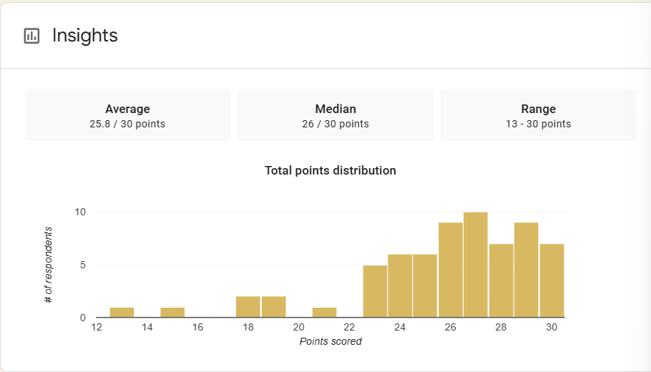

1. Mean Score: The mean score of 25.8 out of 30 indicates a very high average performance. This corresponds to 86%, suggesting that, on average, participants demonstrated strong understanding or proficiency in the tested material.

2. Median Score: The median (middle score) is 26, slightly higher than the mean. This implies that more than half of the participants scored at or above 26.

3. Range: The range is 17 points (from 13 to 30), showing some variability in performance. While most did very well, there are a few lower-scoring individuals (as low as 13), which slightly lowered the mean.

Interpretation Summary:

-The overall performance is very high, with both the mean (25.8) and median (26) near the top end of the scale.

-The distribution is fairly balanced, though a few lower scores (as low as 13) slightly reduced the mean.

-These results suggest that most participants mastered the material, but targeted support may be beneficial for the few lower performers.

RATIONALIZATION:

DIFFICULT QUESTIONS:

